**Lab: Lab 3**

**Registration number: 1703055**

|  |
| --- |
| **Problem statement(s)**  The purpose of this lab is to build on the JSwing principles learnt over the last couple of weeks and from last lab to create a simple shape drawing application to draws shapes and calculate their areas. With this lab I was able to build on creating and utilising methods for different objects and so building upon class inheritance. |

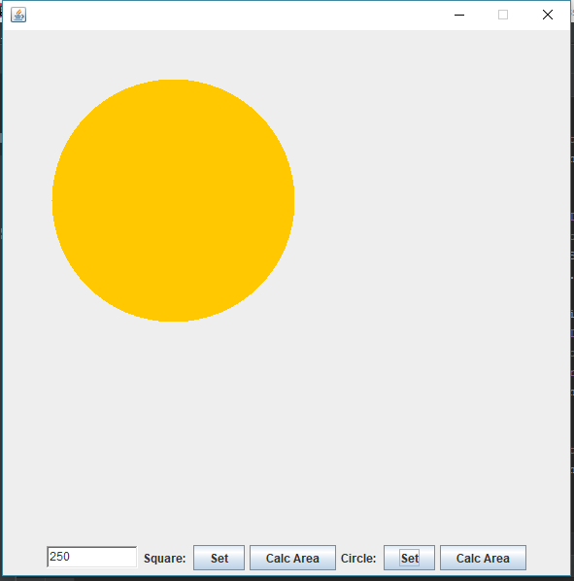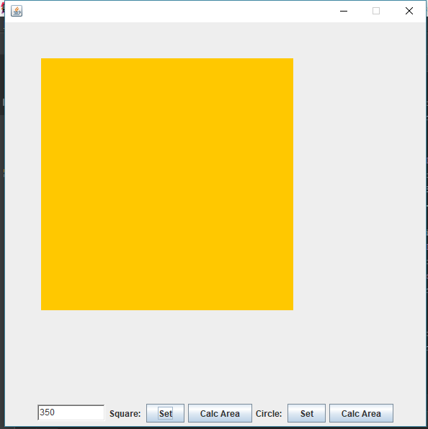

|  |
| --- |
| **Program description(s)**  *Exercise 1:* Within the first exercise, I created a new project as requested and created a new class which extends JFrame. All which encapsulates the button handlers and drawing methods for the relevant circle or square to display with the set and calc area buttons. In another class I created a *Square* and *Circle* class which extend the *Shape* class – this super class initializes the objects with attributes of the posY and PosX as well as side length. Then the individual Square and Circle class have methods relevant to the particular shape. This is for drawing the shape itself or displaying relevant info. Demonstration of initial state and drawing of two shapes below    *Exercise 2:* Within the second exercise, I extended the shape class to include circle shapes. Additional methods for setting the radius and finding the area of the shape were added to all to be called by the existing buttons created.  *Exercise 3:* Finally, added additional methods to both shapes to draw them to the panel |
| **Test description**  ***Exercise 1:***  Test 1: does the frame launch successfully with all buttons and fields  Result 1: Yes frame launches of a suitable size and all components present.  Test 2: do the items launch in a suitable structure and UI  Result 2: Pass, Yes as shown below.    ***Exercise 2:***  Test 1: Can a circle object be created – utilising the circle class which extends shape  Result 1: PASS, with new Circle(…) a new object has been successfully made.  ***Exercise 3:***  Test 1: Are both circle and squares able to be drawn to the frame  Result 1: Pass, as shown in previous screen shots, bot squares and circles can be drawn with whatever size is inputted  Test 2: Can the correct area of any shape been calculated?  Result 2: With the calc area button pressed a JDialogue box will appear with the area of the shape it corresponds to. |
| **Known bugs**  None |
| **Possible improvements**  Could make the UI more appealing with the use of dropdowns or menus. |
| **Comments**  The *setLength()* method outlined in the lab exercise for *Shape* objects is not a good name for the method. As with all different types of shapes they extend the *Shape* class and so all objects will have to have this method; it is important that it is named correctly.  It is appropriately named for squares for setting the length of the square. However for circles *setLength*() is not an appropriate name as it is changing the radius.  With this, I have changed my *setLength*() method to *setSize*() so that the name is more appropriate for all shape objects, may they be squares, circles or more. |
| **Extra credit**  Use of J Dialog box to show the area of the shape. Rather than shown on the panel somewhere. |
| **References**  None other than the lecture slides. |